MODULE 11: DISTRIBUTED TRACING AND MONITORING

Sub-task 1 – CloudWatch

Create CloudWatch Rule to make your lambda run on weekly base.

Update your lambda by adding some logging (For example, execution date time). Trigger you lambda manually and ensure CloudWatch logs were created.

Explore CloudWatch metrics for your EC2 instances by visiting the Monitoring tab. Make some interactions with your application and verify changes for the next metrics:

* CPU Utilization
* Network In
* Network Out

Create CloudWatch Alarm for the EC2 instance CPU Utilization

Specify the threshold that is to trigger the alarm to go to ***ALARM*** state if the CPU utilization exceeds any percentage, for example, 50.

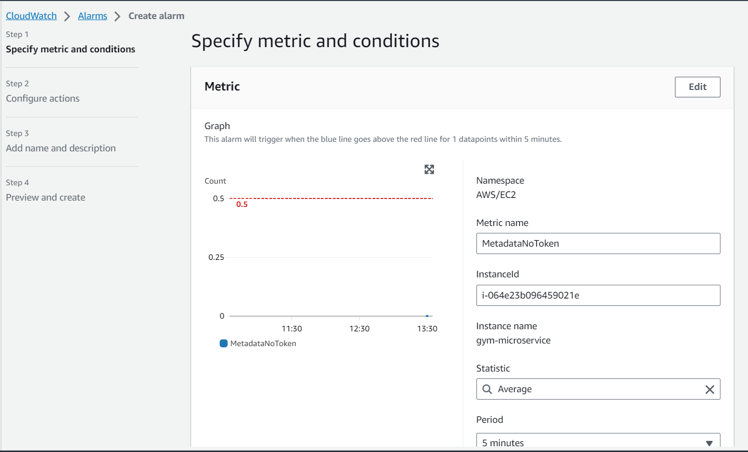

Select an SNS topic from [Module 8: SNS/SQS](/epmc-acm-public/aws-associate-training/-/blob/CloudX_Associate_AWS_Java_TShape_Developer_theory_impovements/courses/CloudX_Associate_AWS_Java_TShape_Developer/tasks/sns_sqs/README.md) to notify when the alarm is in ***ALARM*** state.

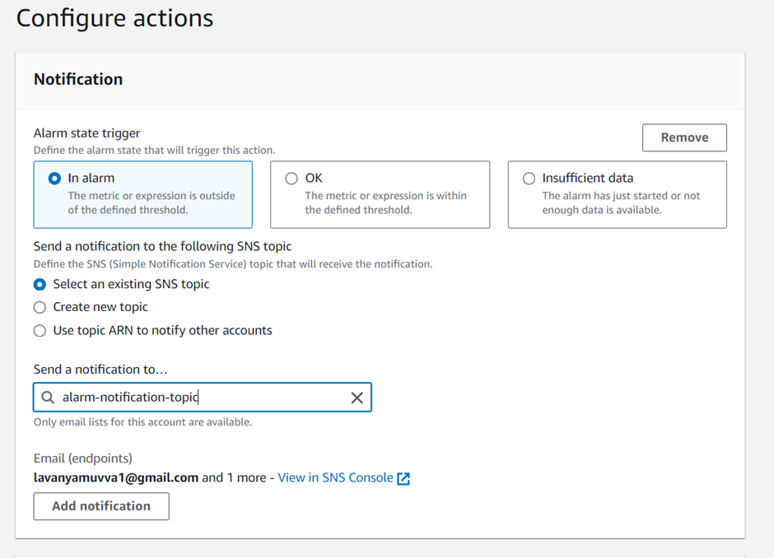

Try to modify alarm limit percentage by setting lower value. Verify notification message when the alarm will reach ***ALARM*** state.

Sub-task 2 – CloudTrail

1. Visit CloudTrail Dashboard.
2. Explore Event History section

